Resource 6 – Ranking
Purpose: Ranking ladders are excellent for developing the language of evaluation, reasoning and justification particularly at the end of a lesson or topic. Pupils are required to consider all the information they have learnt and use them to reason, justify and convince.
Suitable for:
KS1 | KS2 | KS3 | KS4 | KS5 | Subjects
 |  |  |  |  | En, Ma, Sci, Humanities, Languages, Music, Art, Drama, PE, DT, ICT

How to use a Ranking ladder
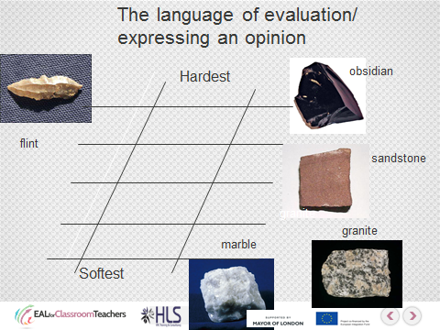

Worked example of a Ranking Ladder KS2

